Date: 11-10-21
WEBLEM 6
Introduction to Specialized Databases

Specialized Databases:
Specialized databases are a collection of focused information on one or more specific fields of study. This information or data is arranged or indexed so that the user can locate and retrieve it quickly and easily.

Features of specialized databases:
- Guaranteed Authoritative information
  - Specialized databases often have strict guidelines on the types of articles and journal sources that are accepted. By searching a database, the articles you find are more likely to be both accurate and reliable.
- They’re Tailored to specific subjects and fields of study
  - The databases outlined in this module are geared towards specific subjects (i.e) medicine, nursing, etc.). When you use these for your research, the articles you find are more likely to be relevant towards your area of study.
- They Provide Full-text and diagrammatic access
  - When accessing these databases you get full text and diagrammatic representation of data available in simple and easy to chunks.

KEGG:
While the genome sequencing projects rapidly determine gene catalogs for an increasing number of organisms, functional annotation of individual genes is still largely incomplete. KEGG (Kyoto Encyclopedia of Genes and Genomes) is an effort to link genomic information with higher order functional information by computerizing current knowledge on cellular processes and by standardizing gene annotations.
Generally speaking, the biological function of the living cell is a result of many interacting molecules; it cannot be attributed to just a single gene or a single molecule. The functional assignment in KEGG is a process of linking a set of genes in the genome with a network of interacting molecules in the cell, such as a pathway or a complex, representing a higher order biological function.

OMIM:
Online Mendelian Inheritance in Man (OMIM), a continuation of Dr Victor A. McKusick’s Mendelian Inheritance in Man (MIM) (1), is the primary repository of comprehensive, curated information on genes and genetic phenotypes and the relationships between them. MIM was published through 12 editions between 1966 and 1998, and OMIM has been online and searchable since 1987.
With the advent of new sequencing technologies, there is a rapid increase in the reports of presumed gene-phenotype relationships. OMIM.org was created to provide a user-friendly and easily searchable portal to a curated compilation of the literature to aid in clinical and molecular genetic research.

References:
- Hamosh, A. (2004). Online Mendelian Inheritance in Man (OMIM), a knowledgebase of human genes and genetic disorders. Nucleic Acids Research, 33(Database issue), D514–D517. https://doi.org/10.1093/nar/gki033
- Kanehisa, M. (2000). KEGG: Kyoto Encyclopedia of Genes and Genomes. Nucleic Acids Research, 28(1), 27–30. https://doi.org/10.1093/nar/28.1.27
Date: 11-10-21
WEBLEM 6a
(url: https://www.genome.jp/kegg/)
Aim:
To study the AKT Pathway using KEGG Database:

Introduction:
The KEGG database project was initiated in 1995 under the Japanese Human Genome Project, foreseeing the need for a reference resource that would enable understanding of the biological systems, such as the cell and the organism, from genome sequence data. Major efforts have been undertaken to represent the biological systems in terms of molecular networks (molecular wiring diagrams), especially in the form of KEGG pathway maps that are manually created by capturing knowledge from published literature. Continuous efforts have also been made to develop and improve the KO (KEGG Orthology) system for representation of gene/protein functional orthologs in molecular networks.

- KEGG PATHWAY is a collection of manually drawn pathway maps representing our knowledge of the molecular interaction, reaction and relation networks for:

- KEGG BRITE is a collection of hierarchical classification systems capturing functional hierarchies of various biological objects, especially those represented as KEGG objects. They are represented as BRITE hierarchy files, also called hierarchical text (htext) files, supplemented with BRITE table files using html tables.

- The KEGG MODULE database consists of KEGG modules identified by M numbers and KEGG reaction modules identified by RM numbers, which are manually defined functional units of gene sets and reaction sets, respectively. KEGG modules are further divided into pathway modules and signature modules as shown below.
  - Pathway modules – functional units of gene sets in metabolic pathways, including molecular complexes.
  - Signature modules – functional units of gene sets that characterize phenotypic features.
  - Reaction modules – functional units of successive reaction steps in metabolic pathways.

Protein kinase B (Akt), similar to many other protein kinases, is at the crossroads of cell death and survival, playing a pivotal role in multiple interconnected cell signaling mechanisms implicated in cell metabolism, growth and division, apoptosis suppression and angiogenesis. Akt protein kinase displays important metabolic effects, among which are glucose uptake in muscle and fat cells or the suppression of neuronal cell death.
Disruptions in the Akt-regulated pathways are associated with cancer, diabetes, cardiovascular and neurological diseases. The regulation of the Akt signaling pathway renders Akt a valuable therapeutic target. The discovery process of Akt inhibitors using various strategies has led to the identification of inhibitors with great selectivity, low side-effects and toxicity. The usefulness of Akt emerges beyond cancer therapy and extends to other major diseases, such as diabetes, heart diseases, or neurodegeneration.

Methodology:
- Open the homepage of KEGG.
- Enter the pathway in search bar.
- Interpret the result.

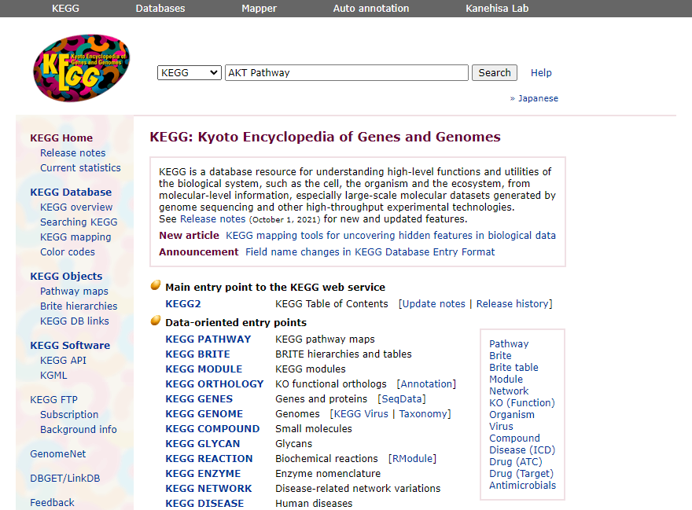
Fig1. Homepage of Kegg with query AKT Pathway
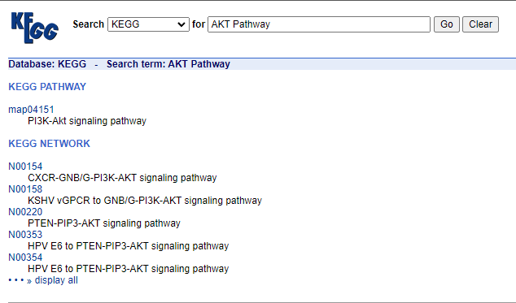
Fig2. Hit page of query AKT Pathway

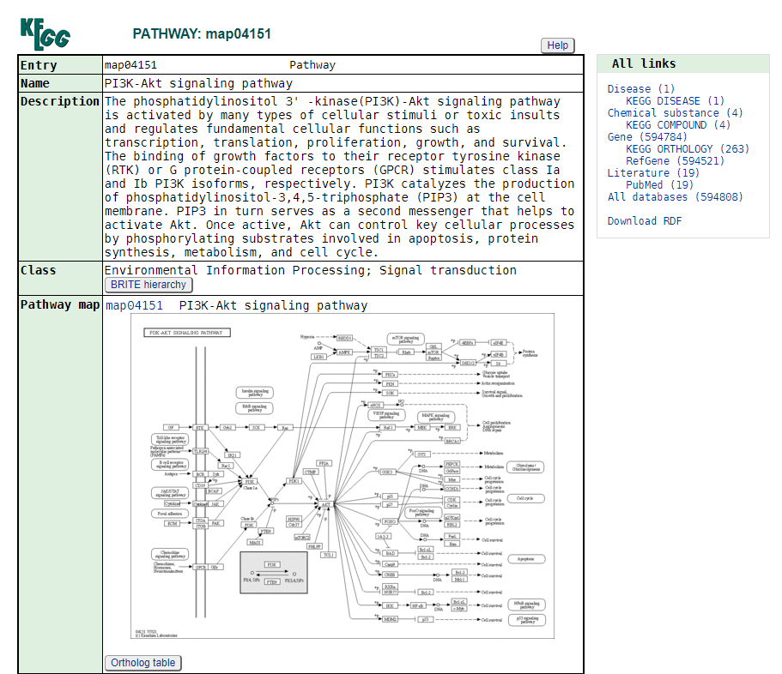
Fig3. Result page for Pathway: map04151
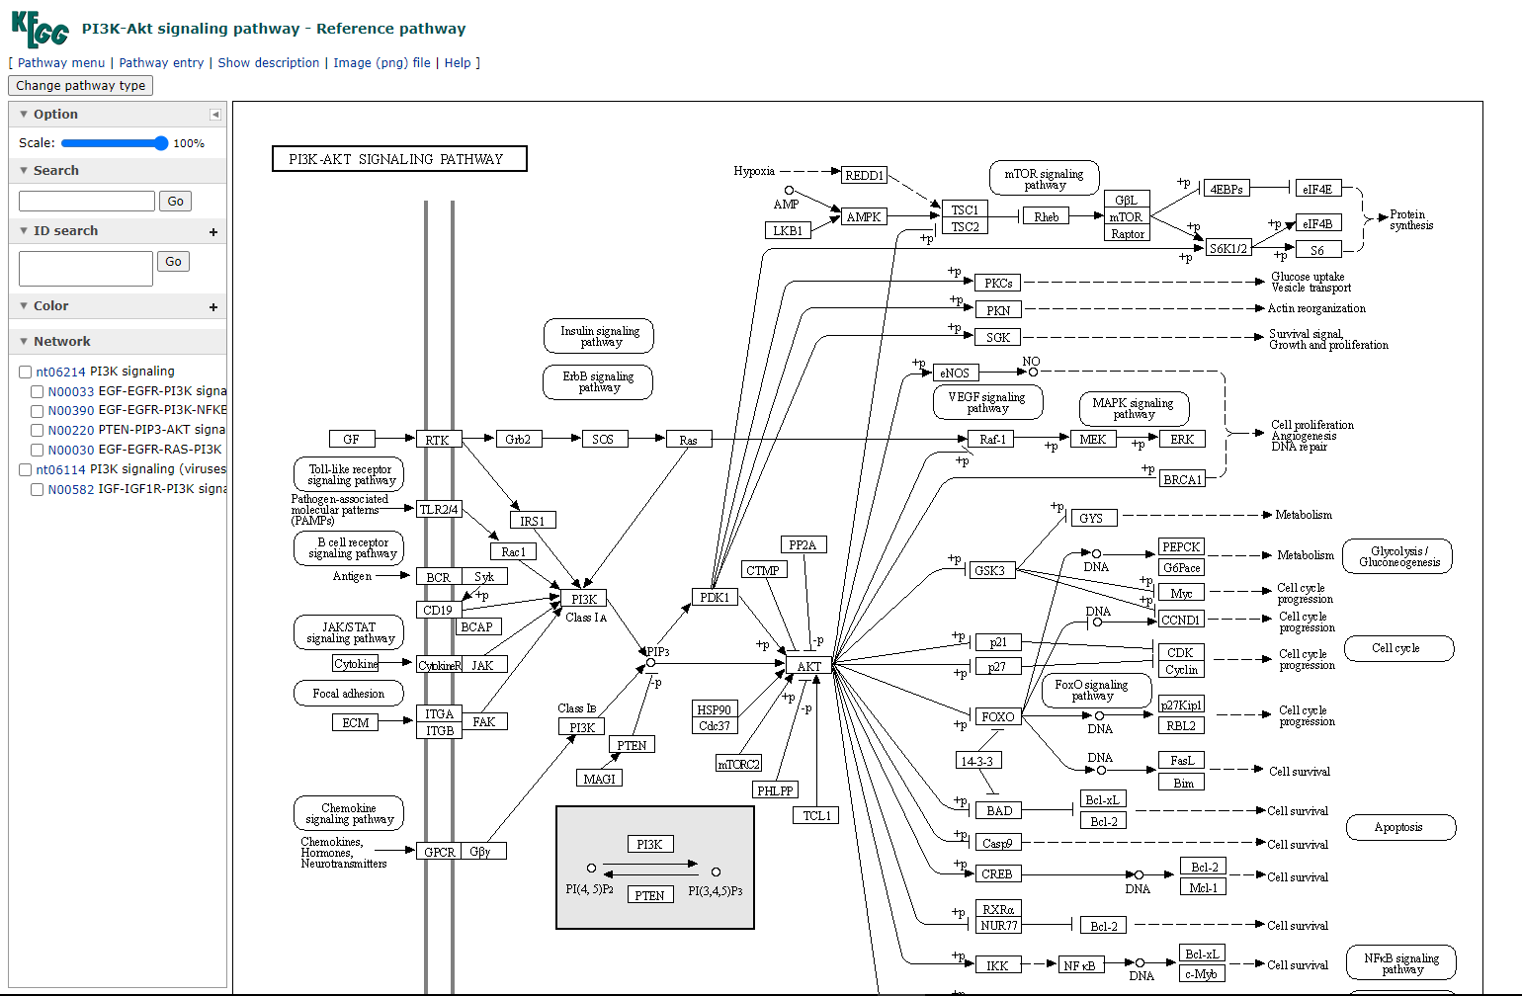
Fig4. AKT signalling pathway – Reference pathway.

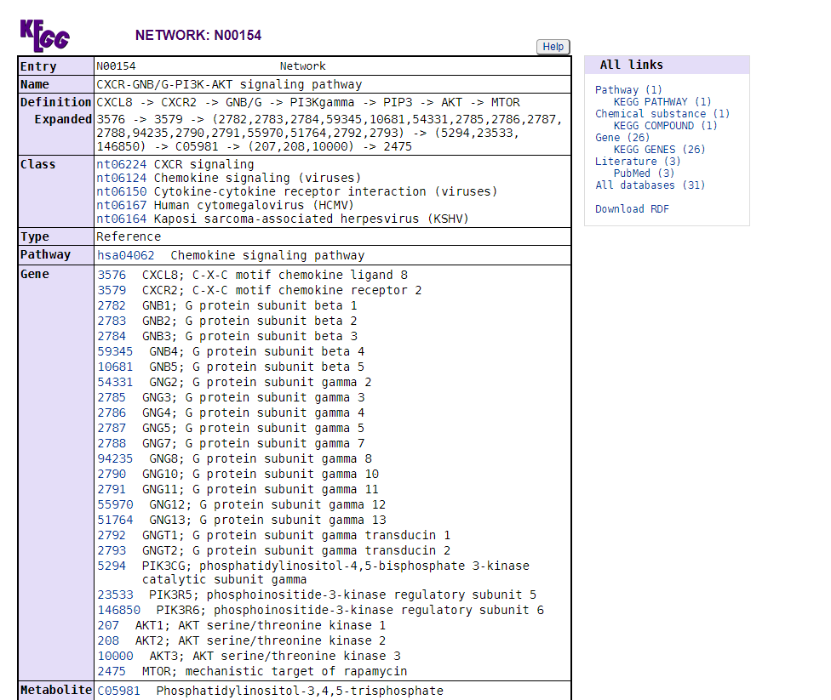
Fig5. KEGG network: N00154

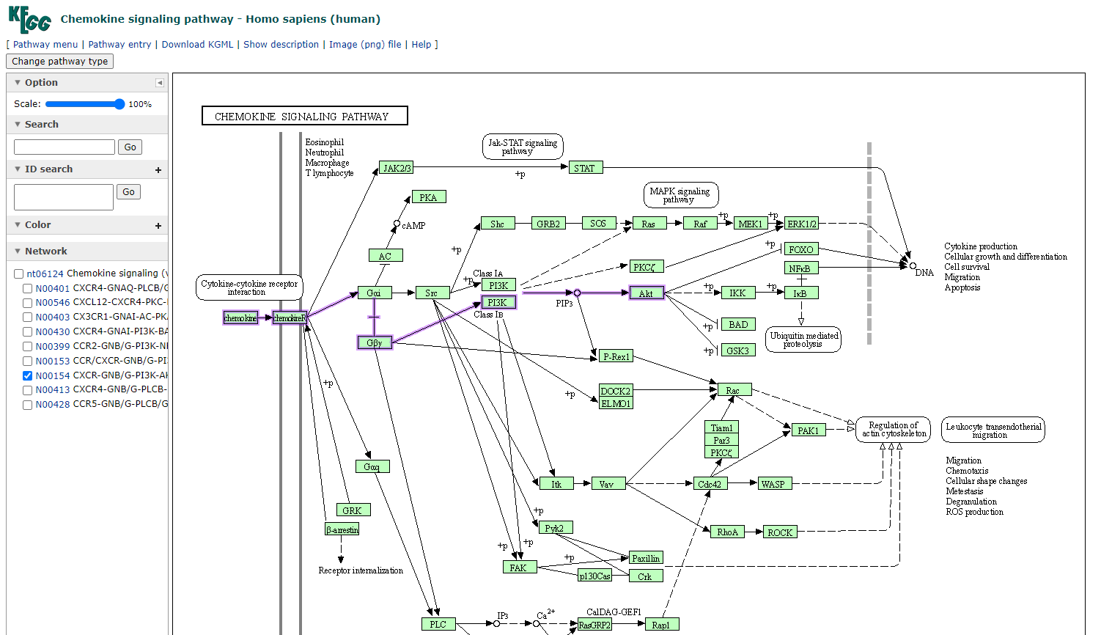
Fig6. KEGG chemokine signalling pathway homo sapiens

Results:
KEGG pathway is a great collection of manually drawn pathway maps representing our knowledge on the molecular interaction and reaction networks.

Conclusion:
KEGG is a great resource for the collection and cross checking of manually drawn pathways and information related to the same.

References:
- The Akt Pathway in Oncology Therapy and Beyond (review) George Nitulescu-Maryna Van De Venter-Georgiana Nitulescu-Anca Ungurianu-Petras Juzenas-Qian Peng-Octavian Olaru-Daniela Grădinaru-Aristides Tsatsakis-Dimitris Tsoukalas-Demetrios Spandidos-Denisa Margina - https://www.spandidos-publications.com/10.3892/ijo.2018.4597
- https://www.genome.jp/kegg/pathway.html
- https://www.genome.jp/kegg/brite.html
- https://www.genome.jp/kegg/module.html
- https://www.genome.jp/entry/map04151
- https://www.genome.jp/pathway/map04151
- https://www.genome.jp/entry/N00154
- https://www.genome.jp/pathway/hsa04062+N00154

Date: 11-10-21
WEBLEM 6b
(url: https://www.omim.org/)

Aim:
To study the disease Sickle Cell anemia using OMIM database.

Introduction:
Online Mendelian Inheritance in Man (OMIM), a continuation of Dr Victor A. McKusick’s Mendelian Inheritance in Man (MIM) (1), is the primary repository of comprehensive, curated information on genes and genetic phenotypes and the relationships between them. MIM was published through 12 editions between 1966 and 1998, and OMIM has been online and searchable since 1987.
With the advent of new sequencing technologies, there is a rapid increase in the reports of presumed gene-phenotype relationships. OMIM.org was created to provide a user-friendly and easily searchable portal to a curated compilation of the literature to aid in clinical and molecular genetic research.

Advanced Search : In advanced search we can find history for our Entry.
Phenotype MIM Number : Main entry.
Genelocus MIM Number : Gene Information.

Symbols:
- Phenotype Description , molecular basis known
- Gene Discription
- Phenotype & Gene Combine
- No Symbol: Other , mainly phenotype with suspected mendelian basis.

Sickle cell anemia is one of a group of disorders known as sickle cell disease. Sickle cell anemia is an inherited red blood cell disorder in which there aren't enough healthy red blood cells to carry oxygen throughout your body. Normally, the flexible, round red blood cells move easily through blood vessels. In sickle cell anemia, the red blood cells are shaped like sickles or crescent moons. These rigid, sticky cells can get stuck in small blood vessels, which can slow or block blood flow and oxygen to parts of the body.
Methodology:
- Open the homepage of OMIM.
- Entry the query in search bar.
- Open the Result page.
- Interpret the Result.

Observation:

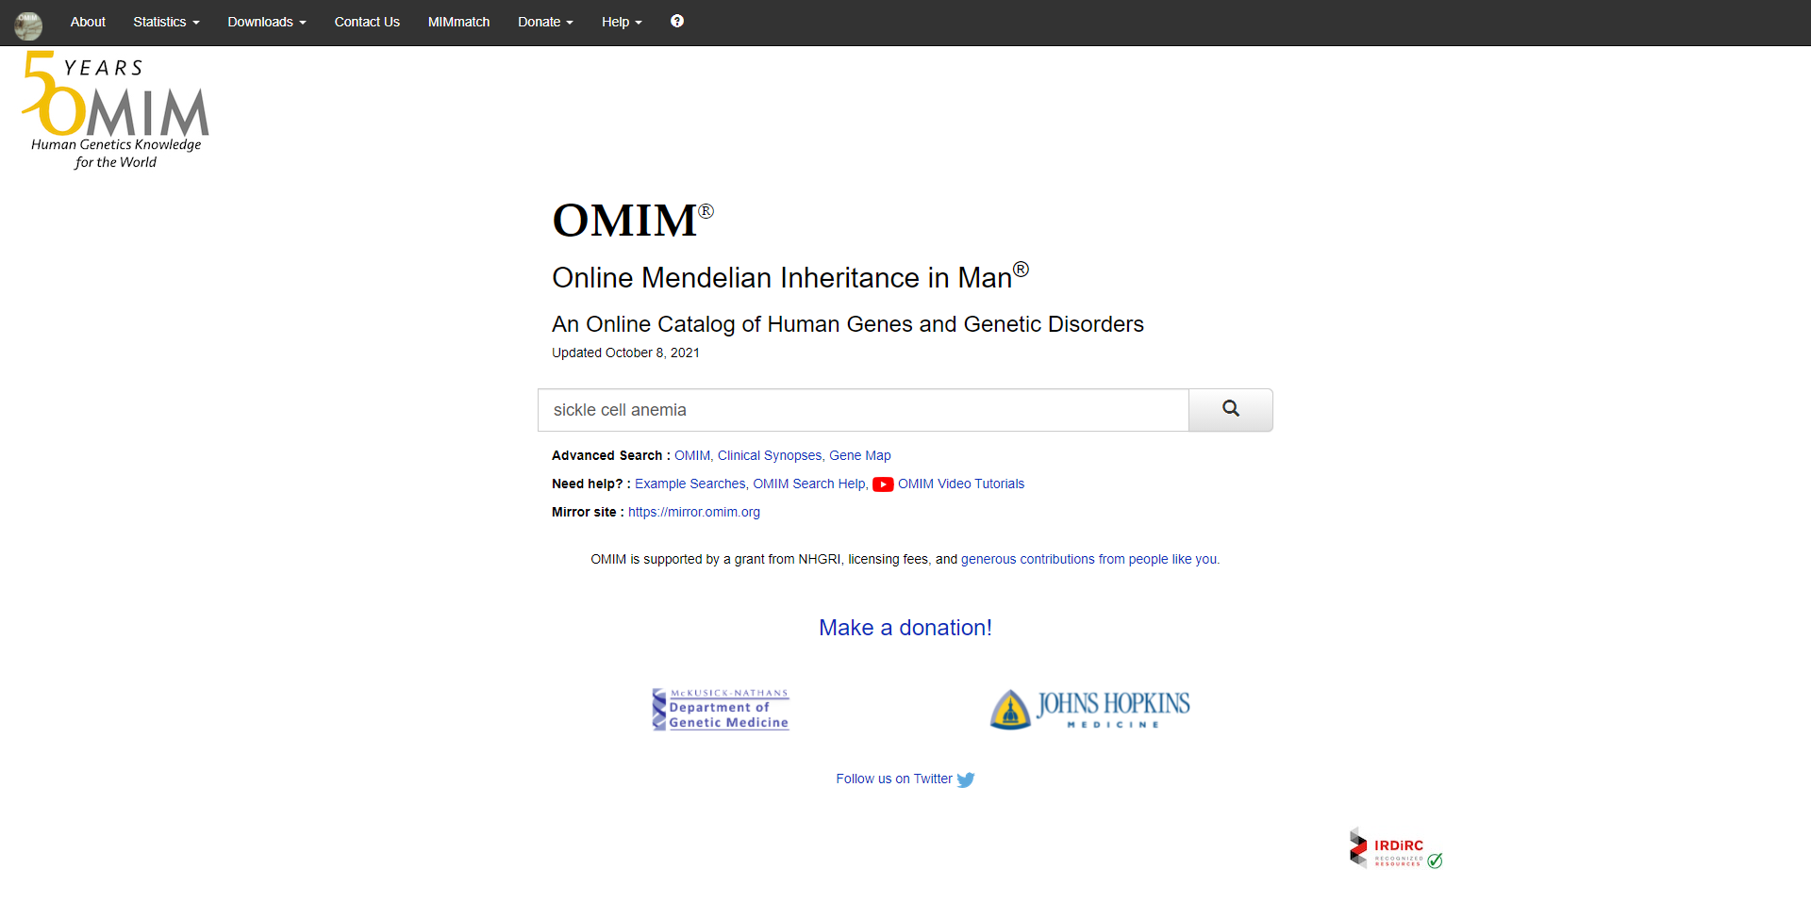
Fig1. Homepage of OMIM with query Sickle cell anemia

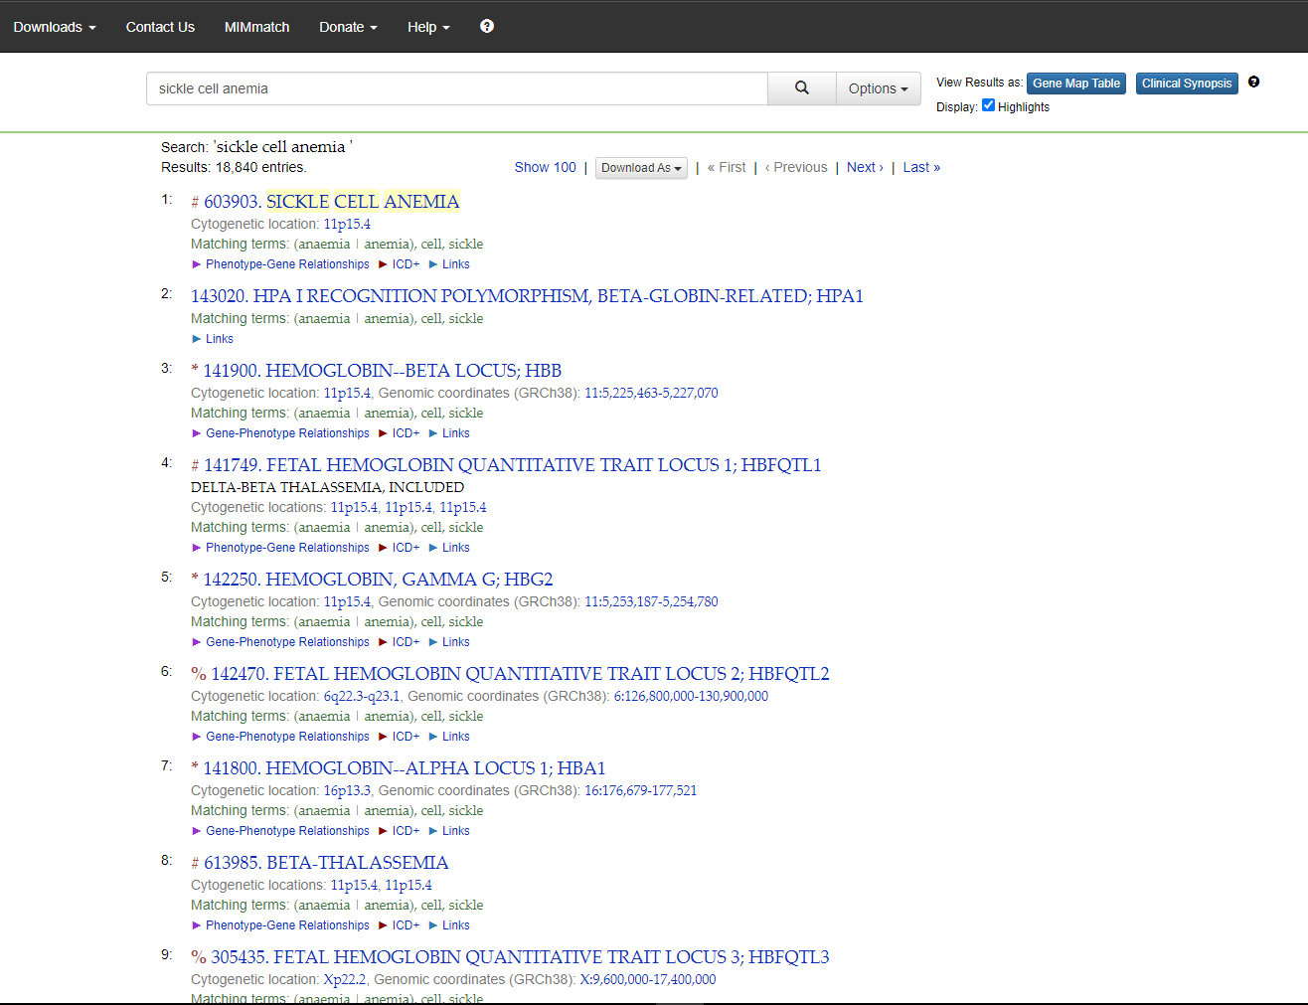
Fig2. Hit page for query Sickle cell anemia showing 18,840 entries

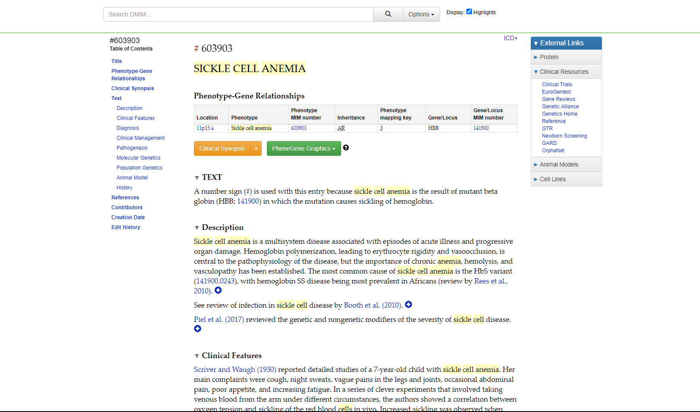
Fig3. Result page for Sickle cell anemia

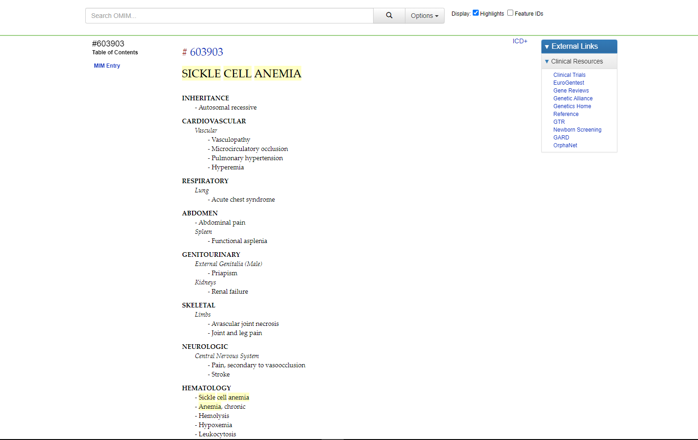
Fig4. Clinical synopsis for sickle cell anemia
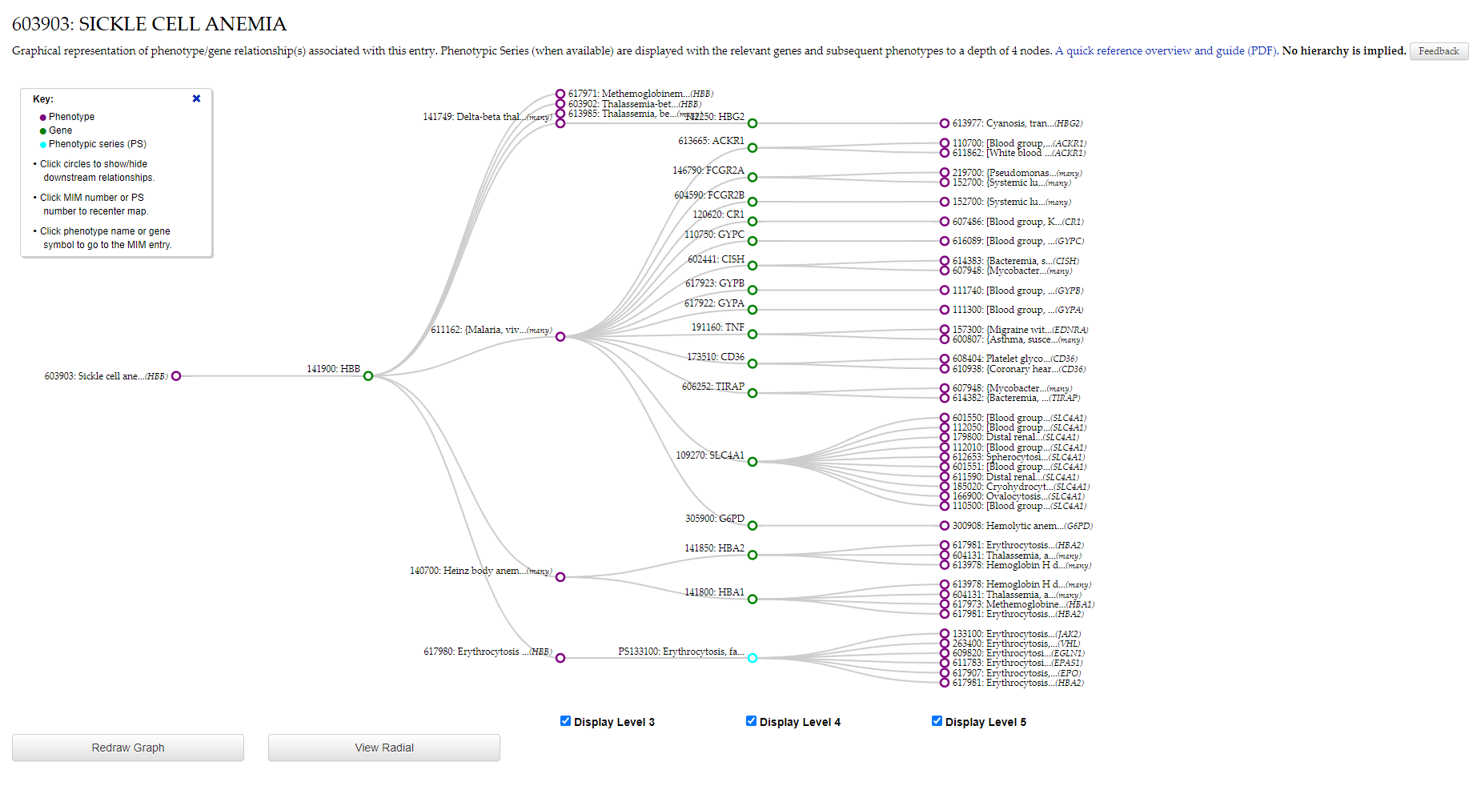
Fig5. Phenegene linear graphics

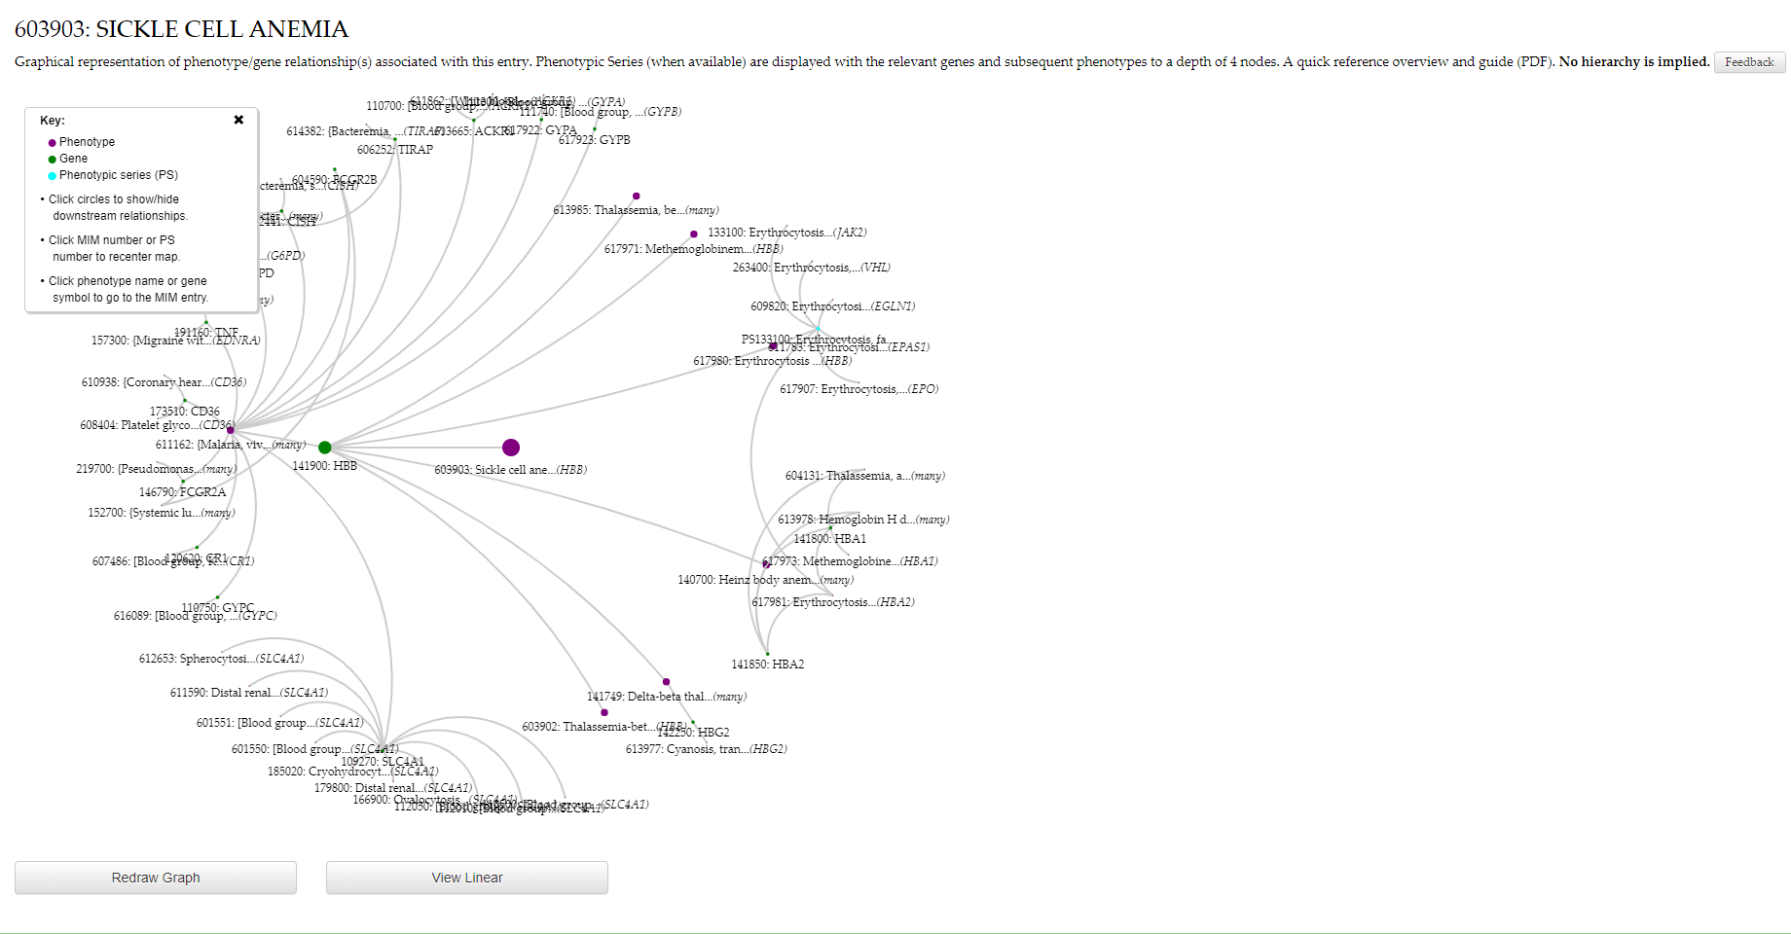
Fig6. Phenegene radial graphics

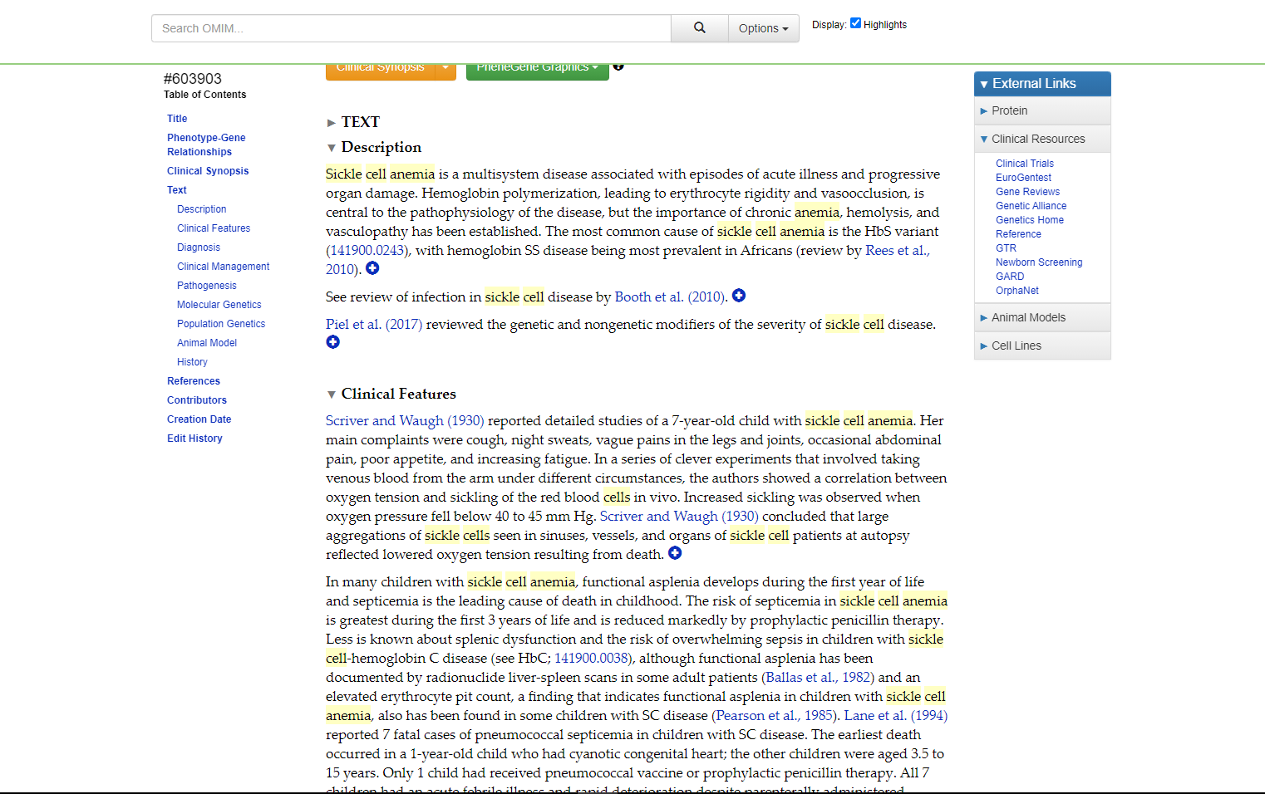
Fig7. Description for query sickle cell anemia

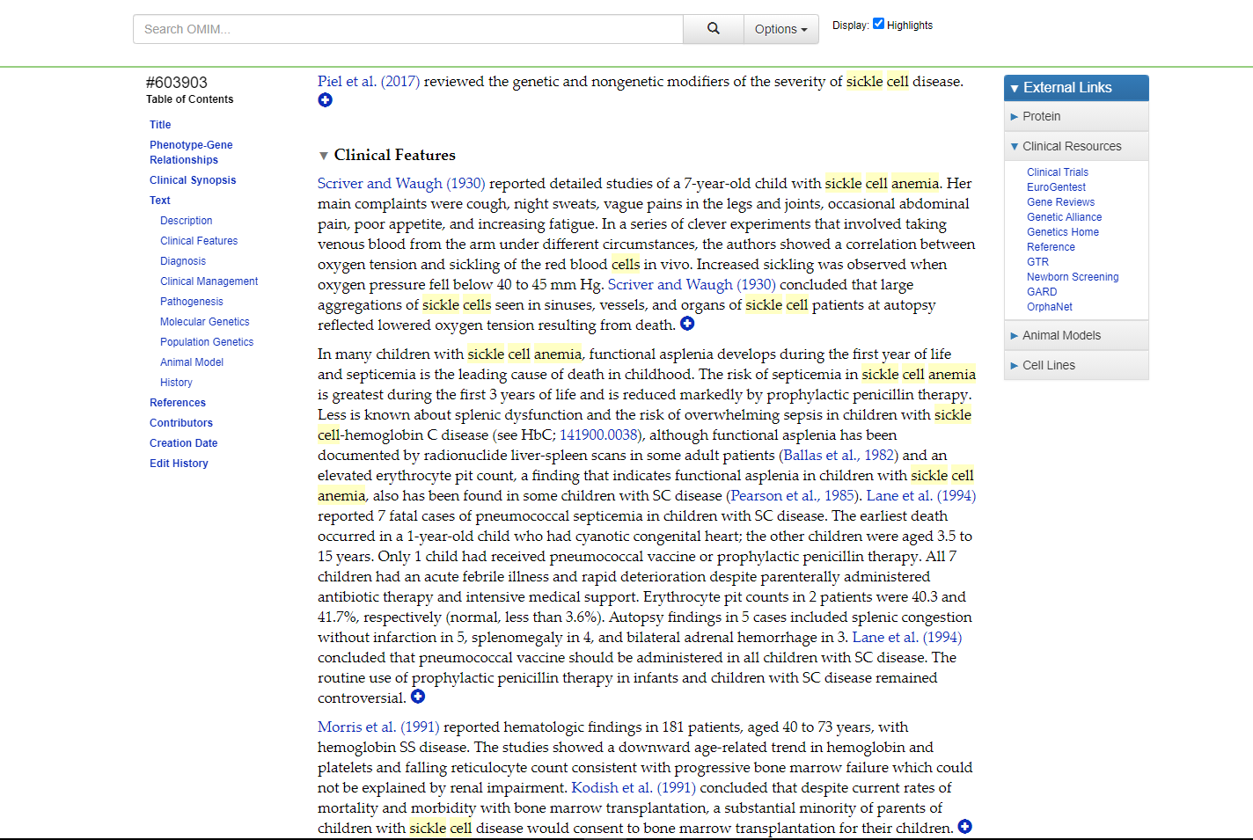
Fig8. Clinical Features for query sickle cell anemia
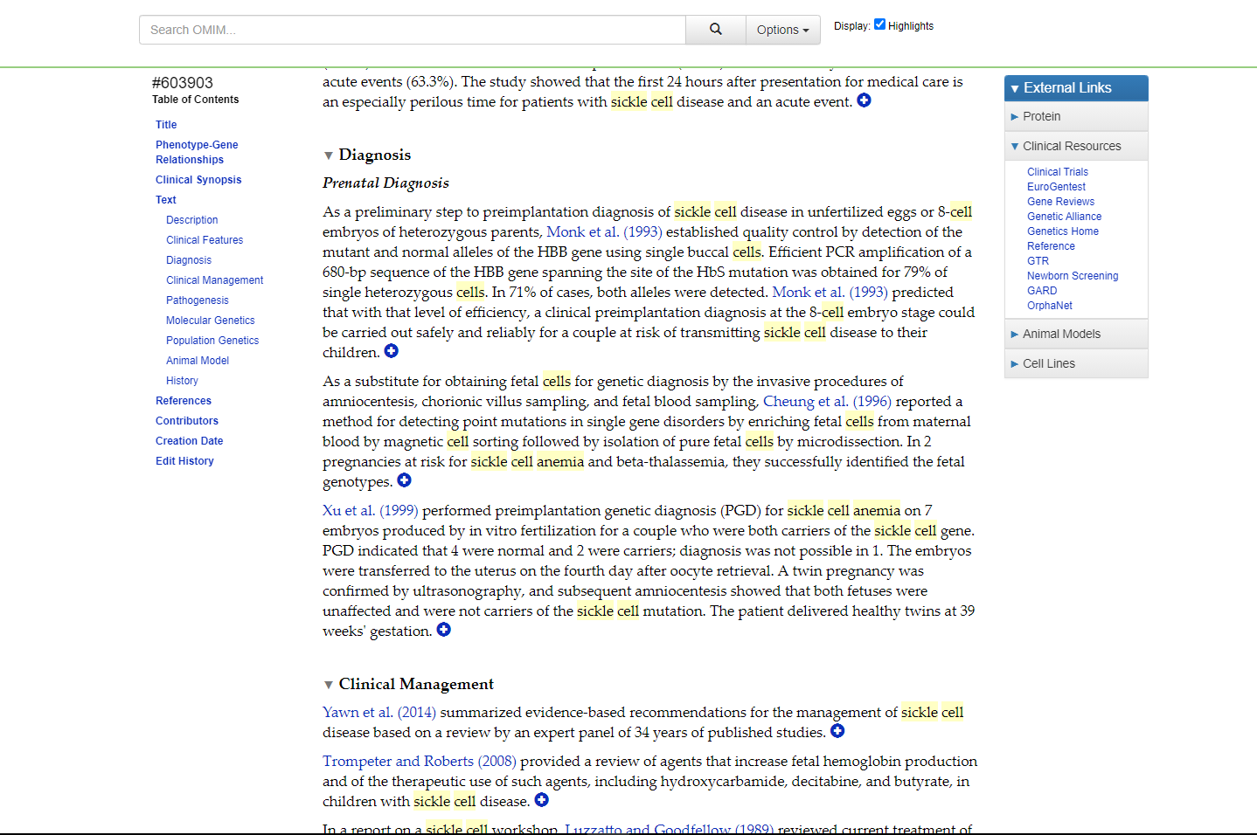
Fig9. Diagnosis for query sickle cell anemia

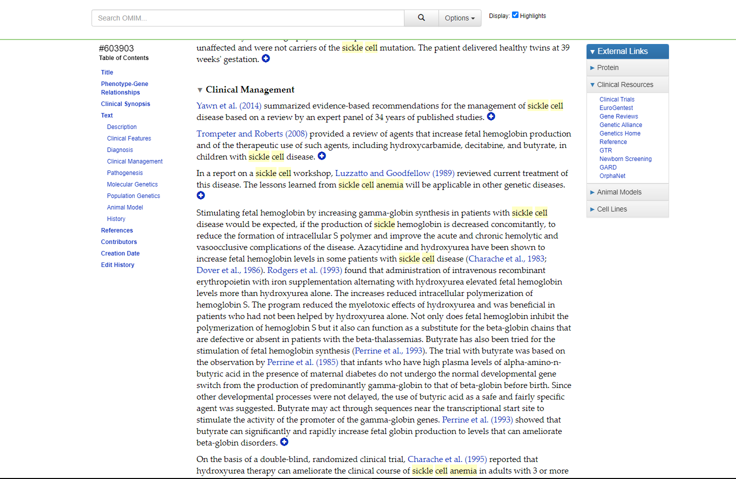
Fig10. Clinical Management for query sickle cell anemia

Results:
In OMIM database the query sickle cell anemia shows 18,841 entries. It gives information regarding Human Genes & Genetic Disorders

Conclusions:
OMIM is a very easy to use and accessible database of human genes and genetic disorders compiled to support human genetics research and education and the practice of clinical genetics.

References:
- https://www.mayoclinic.org/diseases-conditions/sickle-cell-anemia/symptoms-causes/syc-20355876#:~:text=Sickle%20cell%20anemia%20is%20one,move%20easily%20through%20blood%20vessels.
- https://www.omim.org/
- https://www.omim.org/search?index=entry&sort=score+desc%2C+prefix_sort+desc&start=1&limit=10&search=Sickle+cell+anemia
- https://www.omim.org/entry/603903?search=sickle%20cell%20anemia&highlight=%28anaemia%7Canemia%29%20cell%20sickle
- https://www.omim.org/clinicalSynopsis/603903?highlight=(anaemia|anemia)%20cell%20sickle
- https://www.omim.org/graph/linear/603903
- https://www.omim.org/graph/radial/603903
- https://www.omim.org/entry/603903?search=sickle%20cell%20anemia&highlight=%28anaemia%7Canemia%29%20cell%20sickle#description
- https://www.omim.org/entry/603903?search=sickle%20cell%20anemia&highlight=%28anaemia%7Canemia%29%20cell%20sickle#diagnosis
- https://www.omim.org/entry/603903?search=sickle%20cell%20anemia&highlight=%28anaemia%7Canemia%29%20cell%20sickle#clinicalFeatures
- https://www.omim.org/entry/603903?search=sickle%20cell%20anemia&highlight=%28anaemia%7Canemia%29%20cell%20sickle#clinicalManagement

